

Practices for Secure Software Report

Table of Contents
Practices for Secure Software Report 1
Document Revision History 3
Client 3
Instructions 3
Developer 4
1.Algorithm Cipher 4
2.Certificate Generation 4
3.Deploy Cipher 4
4.Secure Communications 4
5.Secondary Testing 4
6.Functional Testing 4
7.Summary 4
8.Industry Standard Best Practices 4

Document Revision History

Version | Date | Author | Comments
1.0 | 02/25/24 | Jake Brewer

Client



Instructions

Submit this completed practices for secure software report. Replace the bracketed text with the relevant information. You must document your process for writing secure communications and refactoring code that complies with software security testing protocols.

- Respond to the steps outlined below and include your findings.
- Respond using your own words. You may also choose to include images or supporting materials. If you include them, make certain to insert them in all the relevant locations in the document.
- Refer to the Project Two Guidelines and Rubric for more detailed instructions about each section of the template.

Developer
Jake Brewer

Algorithm Cipher

One of the most widely used and secure forms of AES encryption algorithms is AES-256. AES-256 is a symmetric encryption algorithm that is used by federal agencies, private sectors and commercial use; as one of the most secure block ciphers. The NIST (National Institute of Standards and Technology) deemed AES as the standard for encryption practices in 2001. AES utilizes various encryption rounds based on key length (128-bit key uses 10, 192-bit uses 12 and 256-bit uses 14). AES uses the key to generate round keys for each respective encryption process, between 10-14 rounds.
SHA-256 is recommend as the appropriate algorithm cipher to deploy. Though while AES-256 is not a has function; SHA-256 can be used as a hash function to ensure authenticity of transmitted data and ensure data is delivered without outside tampering. Comparable to its predecessor SHA-1, SHA-256 security is far superior by producing 256-bit hash, making it almost nearly impossible to generate two different inputs with the same hash value. To create a hash generation in Java, you would create a MessageDirect class with the SHA-256 algorithm.
SHA-256 utilizes random number generation to make unpredictable encryptions, deterring malicious attempts from deciphering the data. The unpredictability of the numbers ensures the patterns are not deciphered or taken advantage of. Since AES is a symmetric algorithm, the same key is used for both encryption and decryption methods. This provides an increase to efficiency when handling large amounts of data encryption/decryption. The caveat to this method is the secure distribution of the keys. If the keys are intercepted; it could render the encryption keys useless.
Prior to AES was the DES method (data encryption standard). The 56-bit key quickly became obsolete as computers became more advanced; breaking the method very quickly. Today's standard utilizes the AES method, which is widely used across multiple applications. With the advancement of technology; more secure forms of encryption will be required as we approach quantum computing.

Certificate Generation
Insert a screenshot below of the CER file.

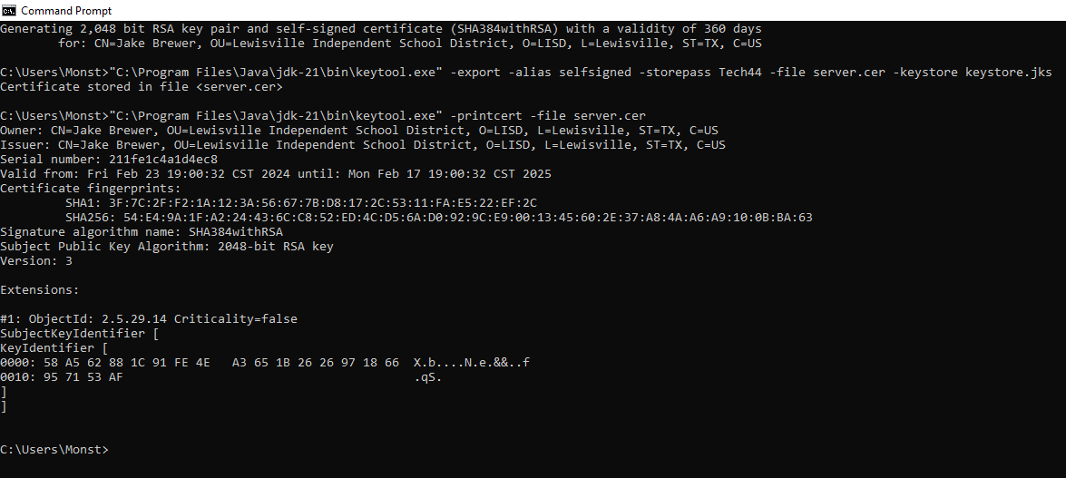

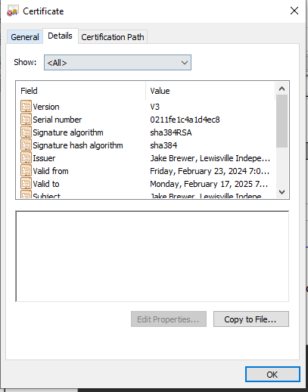

Deploy Cipher
Insert a screenshot below of the checksum verification.

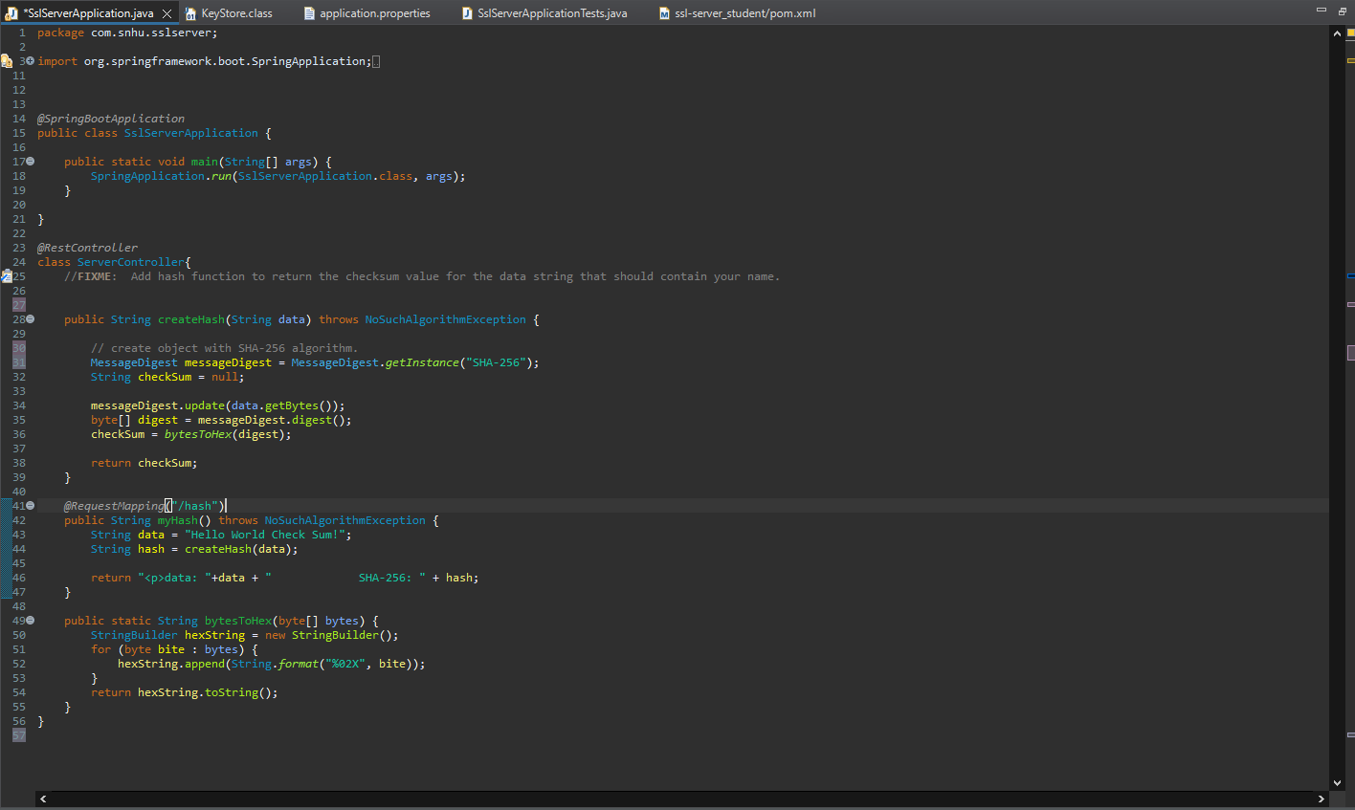

Secure Communications
Insert a screenshot below of the web browser that shows a secure webpage.



Secondary Testing
Insert screenshots below of the refactored code executed without errors and the dependency-check report.

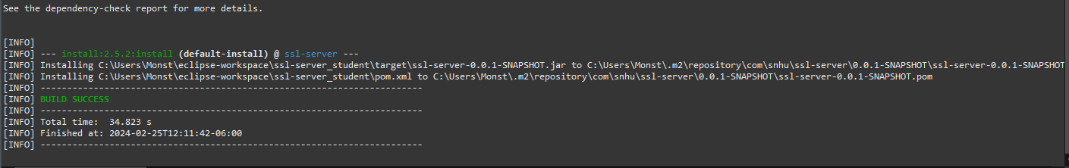
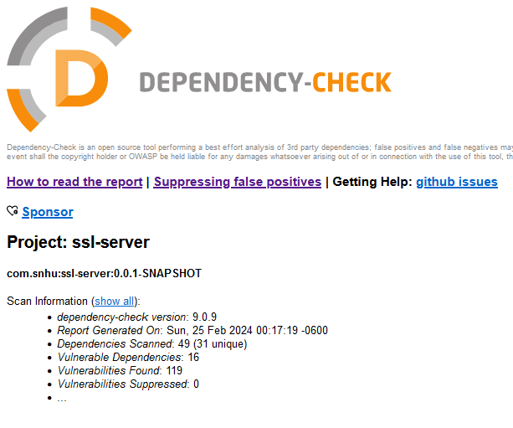

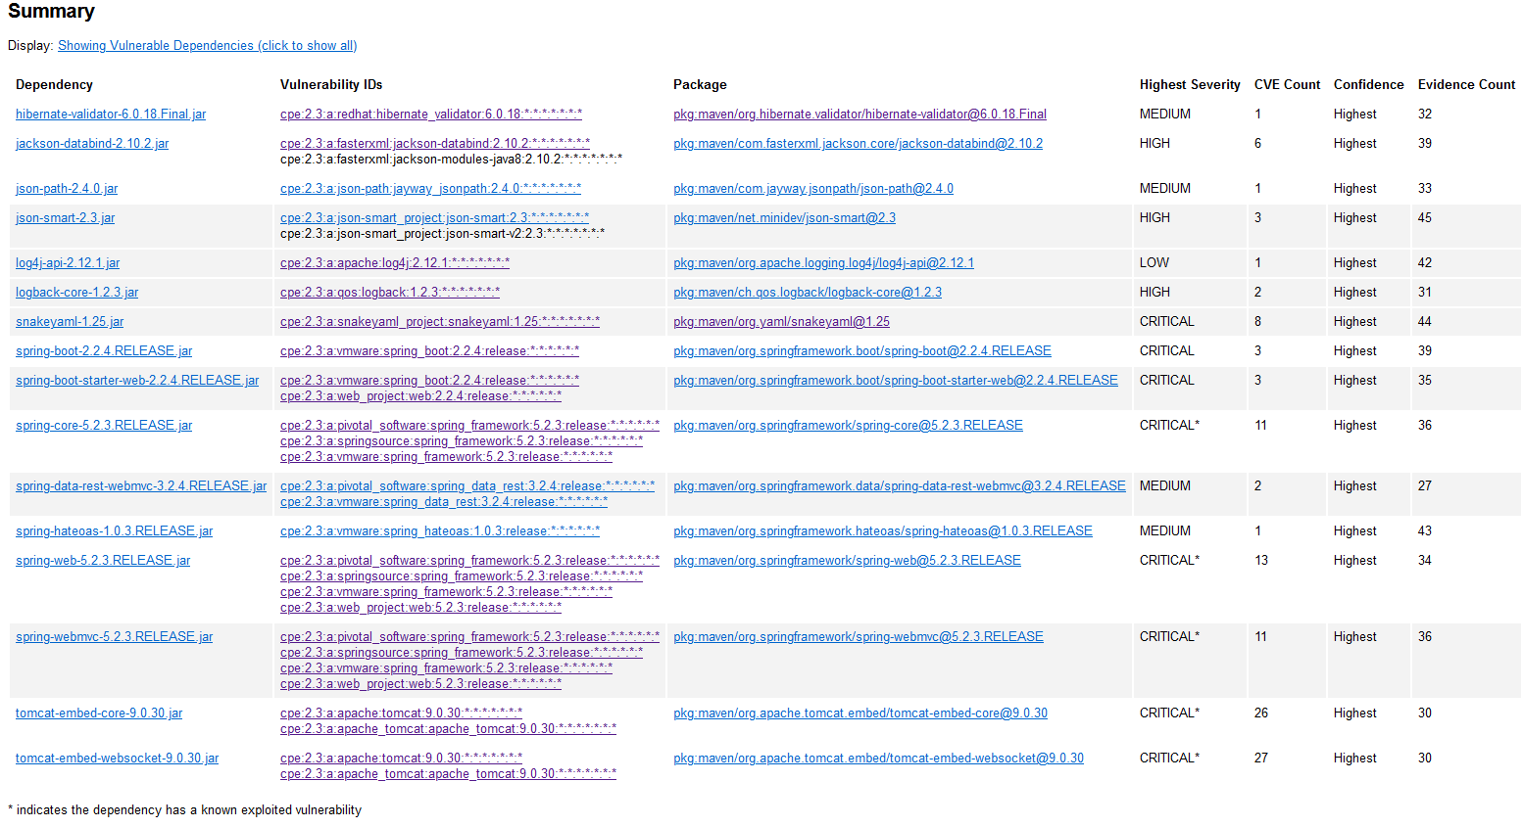

Functional Testing
Insert a screenshot below of the refactored code executed without errors.

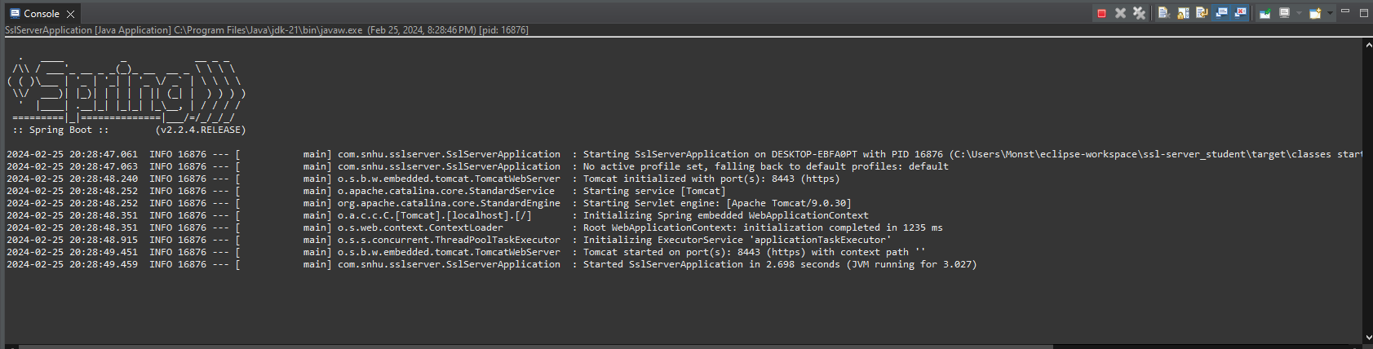

Summary

After reviewing the vulnerabilities assessment diagram; I refactored the code by adding a RestCotroll to the application for the hash RESTful endpoint. Utilizing the SHA-256 hash function provides the most consistent and secure encryption method against attacks. The SHA-26 checksum is nearly impossible of collisions, generating the same number set. This method allows for secure communications between servers (HTTPS) and clients using the API. Testing the code source after each security layer iteration helps to determine if new vulnerabilities were introduced. This process helps to eliminate new vulnerabilities from being introduced into the source code. If adding a layer of security introduces a new vulnerability; the the security method should be scrapped and and new method assessed.

Industry Standard Best Practices

Training the organization or individual developers on being self-conscious in the security landscape of technology is the beast practice when addressing security risk. While there is no set or specific list of actions to take when approaching software security; many can be used across various sectors of technology. Incorporating a security mindset for best practices into the development process will be result in secure development. Security flaws will be reduced and discovered early in the development cycle while reducing associated cost for fixing the errors. Application flaws will be mitigated from the public, if not eliminated entirely. And over time, developers will gain and learn new security practices to better obtain their project goals; setting a regular standard as they develop code. Secure security methods coincide with user and clients trust as developers work on projects from small business to larges government agencies. Below are methods that can be applied to software security development.
- Validated all user input and sanitize to prevent code injection. Utilize appropriate validation methods to prevent buffer overflows, SQL injections and other attacks.
- Use secure HTTPS protocols to implement multi-factor with authentication. Use authentication methods to ensure users access only the data they need.
- Use secure encryption methods such as SHA-256 to protect sensitive data ranging from personal information, debit/credit card information, passwords or company trade secrets (internal documents).
- Protect and store data by utilizing secure encryption and hashing methods.
- Establish secure coding practices and guidelines to ensure consistent software security throughout the development process. Consistency in coding practices reduces errors and security vulnerabilities from being introduced into the build.
- Periodically conduct code reviews and testing of security vulnerabilities throughout the development process.

Sources:
- Lake, J (2023, October 27th) What is AES encryption and how does it work? Comparitech. https://www.comparitech.com/blog/information-security/what-is-aes-encryption/
- Morris J. Dworkin, Elaine B. Barker, James R. Nechvatal, James Foti, Lawrence E. Bassham, E. Roback, James F. Dray Jr. (2001, November 26th) Advanced Encryption Standard (AES). https://www.nist.gov/publications/advanced-encryption-standard-aes
- Axel Network (2021, May 28th) Encryption: The Past, Present, and Future. Axel Network Products. https://www.axel.org/2021/05/28/history-of-encryption/

